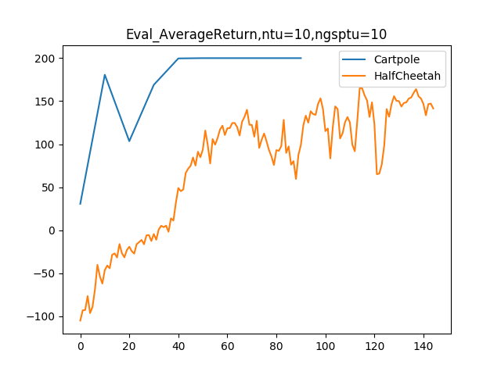

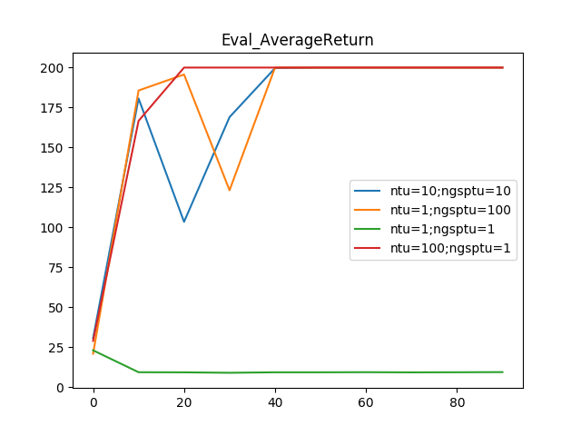

In general when there is linear function estimator function to estimate the Value function the stochastic gradient desecent with TD(0) converge, but when we move towards the non linear function approximation with TD(0) Bootstrap this method does not converge theoritically as well as in practice.